**COMMON ERRORS/MISTAKES MADE BY THE ASSESSEE IN GST COMPLIANCE**

* **A note on Author’s experience gathered in GST compliance Audit**

***(December, 2019)***

**Introduction:**

It has been 2 years since the GST came into operation. Therefore, no formal introduction may be required on GST, and we go into the subject matter directly.

This note compiles the errors/mistakes observed by the Author while performing GST compliance audit during the course of filing GSTR 9 – Annual Return and GSTR 9C - GST Certification.

**Framework:**

The Author has classified the errors/mistakes in two categories:

Errors/Mistakes made in:

Tax Compliance – Results in tax outflow along with Interest

Reporting Compliance – Does not results in tax outflow but may have other consequences at the time of audit performed by GST department

**ERRORS/MISTAKES MADE IN TAX COMPLIANCE:**

1. **Incorrect classification resulting in wrong payment of GST :**

In GST, the type of tax to be charged depends on the “Place of supply”. In simple terms, IGST has to be charged where the supply happens between one state to another and CGST & SGST has to be charged if the supply happens within the state.

Though it looks simple, the rules that decide the place of supply are not as easy for a tax payer to digest.

It was observed that the tax payer in certain occasions has treated an Inter-state supply has intra-state supply or vice versa and has collected a wrong tax.

It is generally assumed that the tax wrongly paid can be adjusted subsequently to pay the correct tax i.e. wrongly paid IGST can be used to remit the correct CGST/SGST liability.

However in this case the GST law requires the tax payer concerned to pay CGST/SGST *(resulting in double payment!!)* and apply for refund for the wrongly paid amount paid as IGST. The tax payer is only relieved from paying interest for this mistake.

1. **ITC availed on Blocked credits:**

With only a small exclusion list, GST law allows an entity to avail input tax credit on its business procurements on fulfilment of the conditions:

Primary conditions:

1. Availability of valid tax invoice as prescribed
2. Actual receipt of goods/services (i.e. no ITC on advances paid)
3. Filing of returns

Additional conditions:

1. Payment to suppliers to be made within 180 days from the date of invoice
2. No ITC allowed if depreciation is claimed on the tax component
3. No ITC on that portion of inward supply used for making exempted supplies

The list of exclusion is covered under section 17(5) of the act. The registered taxpayer is not entitled to avail credit of taxes paid in respect of these listed out goods or services, even if they are used in the course or furtherance of business.

It is generally found by the author that 9 out of 10 tax payers has claimed ITC on such blocked credits as a consequence of which they are forced to pay the same along with interest @ 24% p.a.

For ready reference, the table below shows a list of goods or services on which the Tax payer should not claim ITC.

|  |  |
| --- | --- |
| **List of Expenses on which ITC should not be claimed** | **Example** |
| Purchase of Motor vehicles (*Seating capacity up to 12 passengers*) and other conveyances **used for transportation of office personnel.** | Car / two wheeler purchased in company name either for office or employee use |
| Services of general insurance, servicing, repair and maintenance **in relation to above** | Repairs & maintenance and insurance expenses incurred for company car or two wheeler |
| Food and Beverages | Food and beverage expenses incurred by employees or HO for official purpose.  ***The Author’s recommendation: Wherever the company runs a canteen facility for workers, it is recommended that the company need not claim ITC on expenditure incurred for canteen*** |
| Outdoor Catering | Catering bills for food purchased during Annual day or any function celebrated in office |
| Health Services | Medical treatment or medical bills of employees of the company |
| Membership of a club, health and fitness centre | Membership fees paid for any club by the company |
| Leasing, renting and hiring of motor vehicles for transportation of persons | Car rentals charges incurred by the employees or hired by the company |
| Life Insurance | Life Insurance premium paid by the company for employees |
| Health Insurance | Health Insurance premium paid by the company for employees |
| Travel benefits extended to employees on vacation such as leave or home travel concession | Bills submitted by employees for claiming tax deduction for Leave travel Allowance given by the company |
| Goods or Services used for personal consumption/ personal purpose and not for official use | Expenses not connected to official purpose |
| Goods disposed by way of gift or samples | Business promotion expenses such as gift for marriage, for new clients, Diwali, ramzon gifts, free samples for approval., |

1. **Common Credit – ITC used for both Taxable & Exempt Supplies**

GST Law allows every taxpayer to avail ITC on business procurements that are exclusively used for providing taxable supplies. Wherever such procurements are used for both taxable as well as exempted supply, the tax payer has to reverse that portion of ITC which are in relation to exempted supply. The manner of identifying the proportion is envisaged as under:

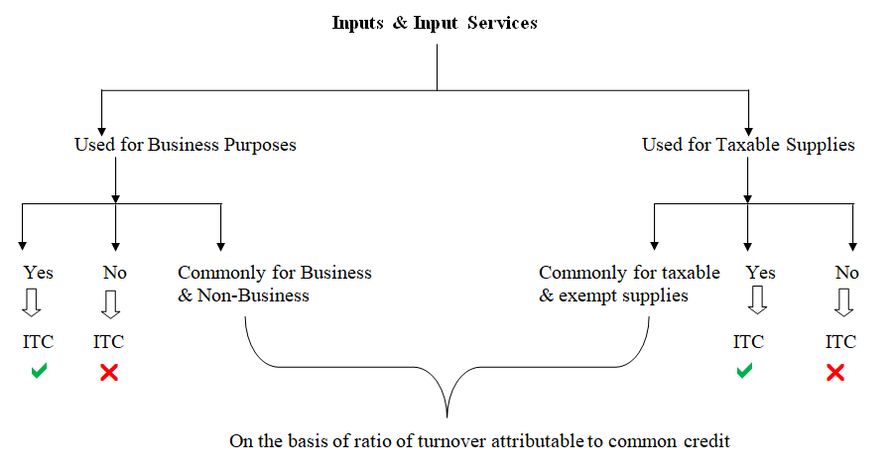

During the compliance review made by the Author it was observed that the tax payers are not very much aware about this provision as they feel that they are not carrying out supplies that are exempted from GST.

For ready reference, the following are some of the important transactions carried out by a company which are exempted from levy of GST:

1. MEIS License sales – Exempted from 13th October 2017
2. High Seas sales
3. Sale of Land
4. **Reverse charge Liability – Non compliance**

As per the GST act, the Company was liable to pay GST on reverse charge basis for the purchases made from unregistered dealers if the purchase from such unregistered dealers exceeds Rs.5,000 per day. This provision was applicable from the 01st July 2017 to 12th October 2017 and was entirely removed thereafter.

Further the company is also liable to pay under RCM for certain notified goods and services the prominent of which are as under:

1. Goods Transport Agency
2. Service of Lawyer/Arbitral tribunal
3. Import of services
4. Security services
5. Sponsorship services
6. Sitting fees or any fees paid to a non-executive director
7. Renting of Motor vehicle to Companies

As per the Author’s observation, most of the companies failed to comply with RCM especially on

1. Unregistered dealer’s procurements
2. Import of services and
3. Sponsorship services

Certain companies continued to pay RCM for procurements from unregistered dealers even after 13th October resulting unnecessary cash outflow.

1. **Payments not made within 180 days – Reversal of ITC not made**

GST Law links the availability of ITC with the payment duration, in respect of supply of goods or services between the vendor and the customer. This aims to restrict the input tax credit of inward supplies received by a taxpayer if the payment towards such inward supplies is not made to the vendor within a period of 180 days from the date of the invoice.

In case the customer fails to make the payment to the vendor within 180 days, he is liable to reverse the ITC on the respective inward supplies and this amount of reversal should be added to the output tax liability for the month in which such reversal becomes due. Additionally, interest at the rate of 18% per annum is to be paid in cash from the date of invoice till the date of reversal of the credit.

It is generally found that, no company has reversed the ITC claimed where the payments to creditors were outstanding beyond 180 days.

It is common knowledge that all exporters were reeling under severe working capital difficulties owing to non-receipt of refund in the first year GST.

Hence in the opinion of the Author, it would be in the fitness of things for the government to waive the condition of 180 days for ITC availed for the incorporation year of GST.

1. **Other Tax- Non compliance**
2. Non-payment of GST on amount collected from employees for providing food and transport facility which are not forming part of employment agreement.
3. Non-payment of GST on advance received for supply of goods (Which was applicable up to 15th November 2017)
4. Non-payment of GST on advance received for supply of service
5. Non Payment of GST for transactions carried out between branches bearing different registrations.
6. Non-reversal of ITC in case of free sample / write off / gift / personal consumption
7. Non-availment of ITC on banking transactions due to non-receipt of invoices or ITC is availed on back statement but not on bank invoice.
8. Non-availment of ITC on air tickets due to non-availability of tax invoice of airline company but took only ITC on Agent’s fees collected
9. ITC of CGST and SGST of one State is wrongly claimed in other State – e.g. GST claimed on Hotel stay

**ERRORS/MISTAKES MADE IN REPORTING COMPLIANCE**

1. The returns of GSTR 1 and GSTR 3B for most of the companies do not handshake with each other on account of non-disclosure or erroneous disclosure.
2. Wrongly reported exports of goods with payment of IGST under normal supplies which resulted in blockage of IGST refund
3. Not carried out reconciliation between GSTR 2A and returns to find out any missed out claim of ITC
4. Reporting of export under LUT as “NIL or exempted supply”
5. Reporting the taxable value of Export of Goods under LUT as “Nil”

**SUMMARY AND RECOMMENDATIONS**

Most of the mistakes cited above arise owing to lack of understanding of the law which has been undergoing frequent changes. However, companies may be able to mitigate this risk by:

1. Instituting a compliance audit mechanism from time to time to ensure that mistakes, if any are immediately addressed, avoiding stiff interest @ 18%/24% and penalties. Timely detection of errors can help in taking ITC wherever missed out and in arresting the application of interest;
2. Customizing accounting software in such a way that all returns such as GSTR 1 and 3B, reconciliation of 2A with Books can be seamlessly done online through the accounting package itself and avoid keeping detailed workings in excel or other tools. This is also important given that there is a restriction on taking ITC *(more about that in the next article)* and this requires periodical matching of ITCs in Books with ITCs in 2A.

****************